**Machine Learning Algorithm**

1. Supervised learning

More commonly .

Input to output **Labled.**

„learn from being given „right answers” “.

Data has “right” answers.

1. Regression (predict a number)
   1. Predicts a number  
      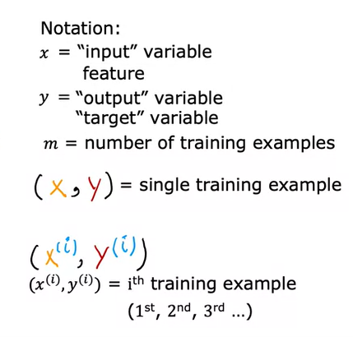 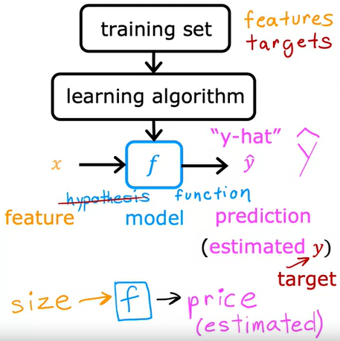

**Linear Regression with one feature**

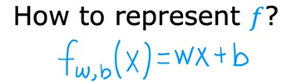

f is a linear function – means only has one variable (**univariate linear regression**)

**w = slope**

**b = interecept**

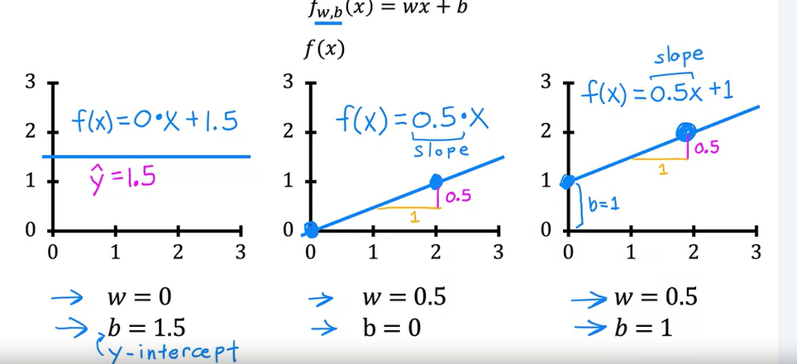

**Cost function**

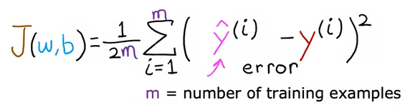

**Goal:** minimize J(w,b) to find the best fitting f(x)

**Gradient Descent**

Find the local minima for the cost function J to minimize it.

Like walking a hill to the valley

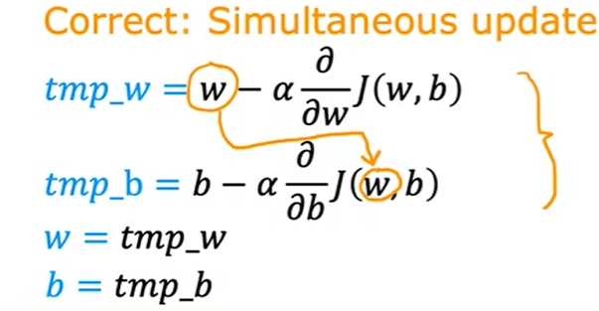

**Multiple features**

Instead of using just one x as a feature like the size of a house we are now going to use multiple features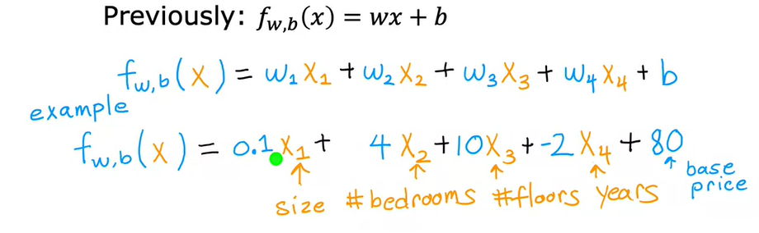

(0.1, 4, 10, -2, 80 are randomly chosen)

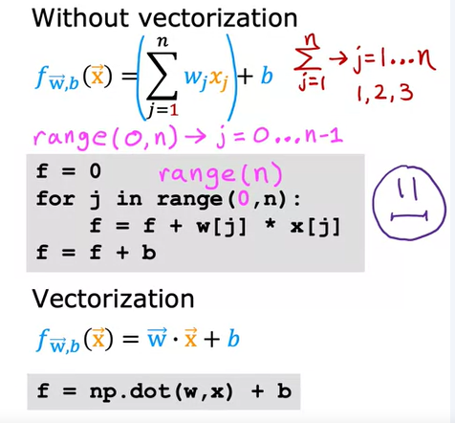

LAB NACHHOLEN WOCHE 2 Mulitple linear regression Lab 2

1. Classification
   1. predicts categories
2. Unsupervised learning

**No labels**

Find pattern / interesting informations in unlabeled data